BIOMEX PROTECTION
It’s all about pushing your limits. Level gloves with Biomex Wrist Protection can help you stay in one piece…so you’ll be riding tomorrow instead of seeing the doctor.
Level’s proven Biomex Wrist Protection system is the result of an extensive and on-going collaboration between snowboarders, the medical community, and engineers who understand bio-mechanics.
Biomex research and development is based at the klinic gut, center of bone and joint surgery in St. Moritz, Switzerland, where Level props and physician design and develop the most advanced wrist support technology on the market – the Biomex Plus.
For beginner, the most frequent cause of a wrist fracture in snowboarding is a backwards fall. For more experienced riders it’s a front and sideways fall. There are many wrist guards on the market, but based on their design, they don’t all deliver the same degree of safety performance.

HOW DO YOU GET HURT?
During a fall your wrist is put in hyper extension. (The back of hand is pushed back towards the forearm). In addition to this hyper extension, the wrist often experiences two types of twisting forces technically referred to as pronation and radial adduction. It’s the combination of these three forces that most often causes a wrist injury such as a wrist fracture.
WATCH VIDEO
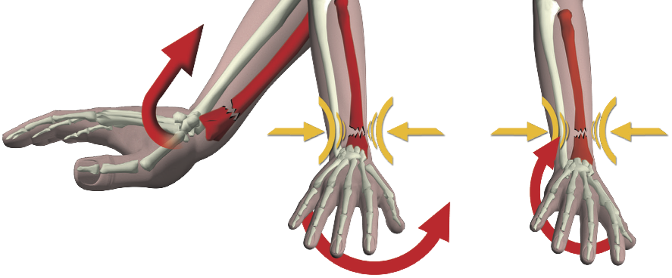
Most wrist guard system deal with hyperextension alone, but the Biomex system addresses all three of the forces that contribute to wrist injury. Standard wrist guards frequently push the fracture farther up the forearm.

WHY IS BIOMEX A BETTER WRIST GUARD?
Biomex is the only wrist guard that keeps the wrist in an anatomically strong position, where muscle.forces and bone congruency combine to provide optimum stability without compromising the freedom to move.
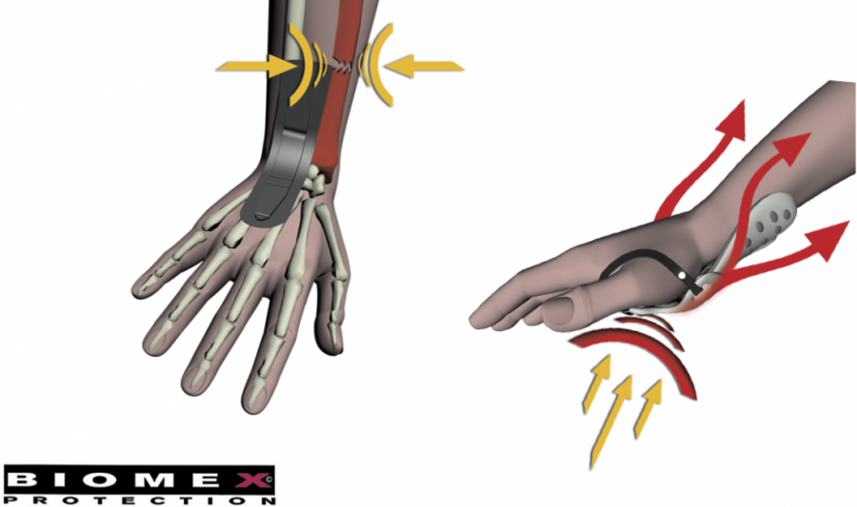

SNOWBOARD PROTECTION
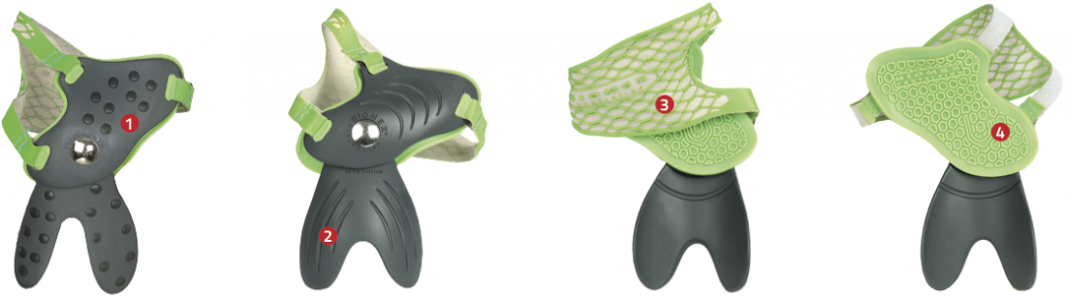

1- DOUBLE DENSITY MATERIAL
HIGHER RESISTENCE AND BETTER COMFORT

2 – SWALLOW TAIL DESIGN
NEW ERGONOMIC SHAPE FOR BETTER COMFORT AND EASE OF MOVEMENT

3 – BIOMEX SELF ADJUSTMENT
THE BIOMEX PIECE CAN BE USED ONLY WITH ITS LINING

4 – SHOCK ABSORBER MATERIAL
SHOCK REDUCTION AND BETTER FIT
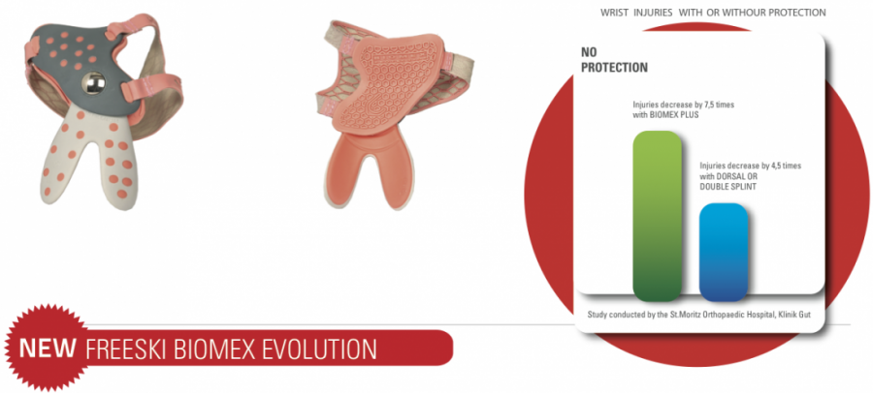

5 – SPECIFIC WOMEN’S FIT
SPECIFICALLY DESIGNED FOR WOMEN’S HANDS FOR IMPROVED FIT AND COMFORT

FREESKI PROTECTION
The new freeski scene is exploring to an higher level and riders need protection while stomping insane tricks.
Thanks to years of experience in the snowboard protection market, Level has developed an innovative Biomex system that provides wrist protection for freeskiers!
The advantage, great grip on the ski pole and higher protection for your wrist!
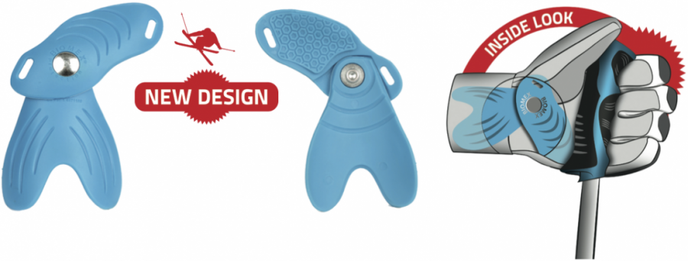
SHORTER AND SOFTER MATERIAL, IT IS ATTACHED TO THE LINING AND FITS ANATOMICALLY TO THE HAND.

